|  |  |
| --- | --- |
| Date | 16 October 2022 |
| Team ID | PNT2022TMID37700 |
| Project Name | Plasma donor application |
| Maximum Marks | 4 Marks |

**Data Flow Diagrams:**

Project Design Phase-II

Data Flow Diagram & User Stories

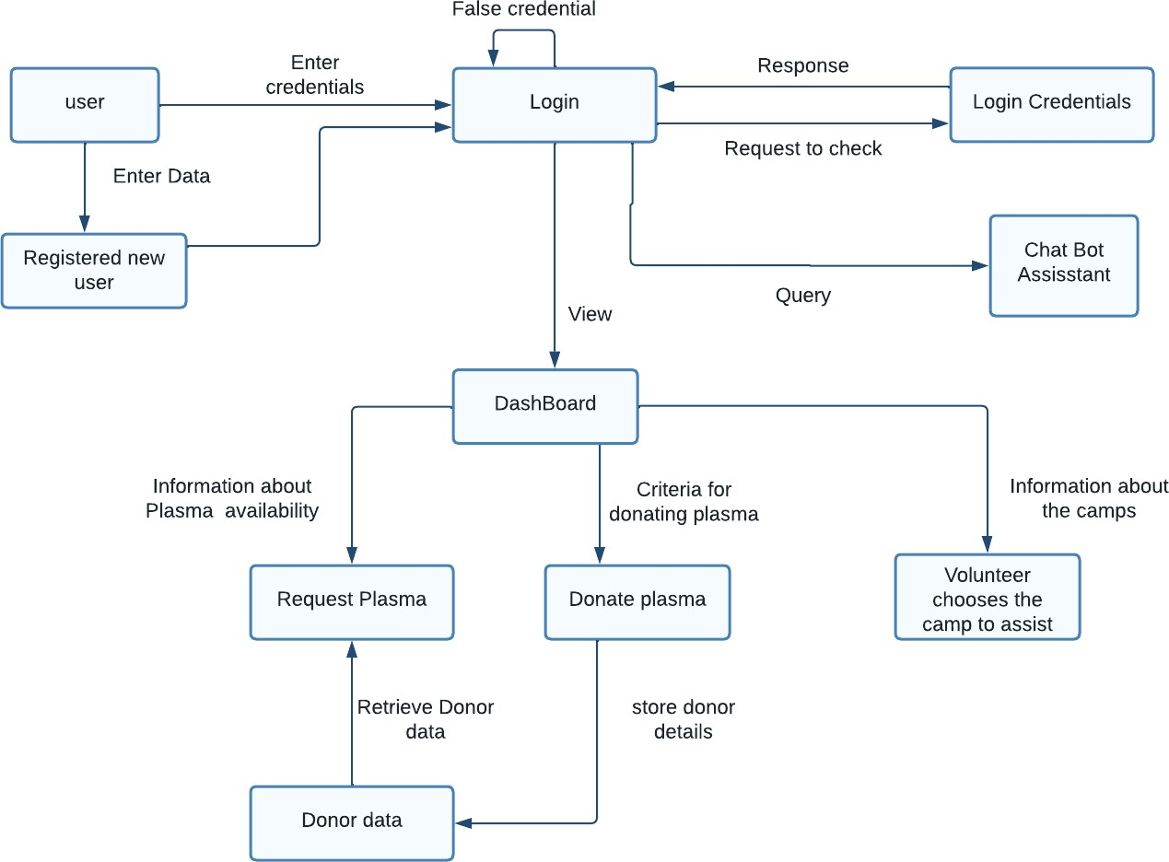

**User Stories**

Use the below template to list all the user stories for the product.

|  |  |  |  |  |  |  |
| --- | --- | --- | --- | --- | --- | --- |
| **User Type** | **Functional Requirement**  **(Epic)** | **User Story Number** | **User Story / Task** | **Acceptance criteria** | **Priority** | **Release** |
| Customer (Mobile user) | Registration | USN-1 | As a user, I can register for the application by entering my email, password, and confirming my password. | I can access my account / dashboard | High | Sprint-1 |
|  |  | USN-2 | As a user, I will receive confirmation email  once I have registered for the application | I can receive confirmation  email & click confirm | High | Sprint-1 |
|  |  | USN-3 | As a user, I can register for the application through Gmail | I can receive confirmation notifications through Gmail | Medium | Sprint-1 |
|  | Login | USN-4 | As a user, I can login to the application by  entering email & password | I can access into my User  profile and view details in dashboard | High | Sprint-1 |
|  | Dashboard | USN-5 | As a user I can send the proper requests to  donate and obtain plasma. | I can receive appropriate  notifications through email | High | Sprint-1 |
| Customer (Web user) | Login | USN-6 | As a user I can register and login to the application by entering email & password to  view the profile | I can access into my User -profile and view details in  dashboard | High | Sprint-1 |
|  | Dashboard | USN-7 | As a user I can send the proper requests to donate and obtain plasma. | I can receive appropriate notifications through email | High | Sprint-1 |
| Customer Care  Executive | Application | USN-8 | As a customer care executive, I can try to  address user’s concerns and questions | I can view and address  their concerns details and questions | Medium | Sprint-2 |
| Administrator | Application | USN-9 | As an admin I can help with user-facing  aspects of a website, like its appearance, navigation and use of media. | I can change appearance and navigation in a user- friendly manner. | Medium | Sprint-3 |
|  |  | USN-10 | As an admin, I can involve working with  the technical side of websites. | I can help with such as  Troubleshooting issues, setting up web hosts, ensuring users have access and programming servers. | Medium | Sprint-1 |

|  |  |  |  |  |  |  |
| --- | --- | --- | --- | --- | --- | --- |
| **User Type** | **Functional Requirement**  **(Epic)** | **User Story Number** | **User Story / Task** | **Acceptance criteria** | **Priority** | **Release** |
| Chatbot | Dashboard | USN-11 | In addition the Customer- care executive chatbot you can try to address user’s  Concerns details and questions | I can reply to all the queries related to our application. | Medium | Sprint-3 |